**Day 7 Task: Understanding package manager and systemctl**

### What is a package manager in Linux?

In simpler words, a package manager is a tool that allows users to install, remove, upgrade, configure and manage software packages on an operating system. The package manager can be a graphical application like a software center or a command line tool like apt-get or pacman.

You’ll often find me using the term ‘package’ in tutorials and articles, To understand package manager, you must understand what a package is.

### What is a package?

A package is usually referred to an application but it could be a GUI application, command line tool or a software library (required by other software programs). A package is essentially an archive file containing the binary executable, configuration file and sometimes information about the dependencies.

### Different kinds of package managers

Package Managers differ based on packaging system but same packaging system may have more than one package manager.

For example, RPM has Yum and DNF package managers. For DEB, you have apt-get, aptitude command line based package managers.

## **Tasks**

1. You have to install docker and jenkins in your system from your terminal using

package managers





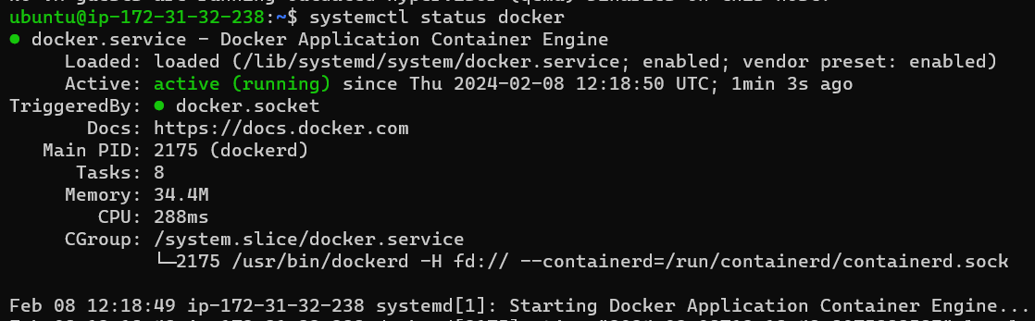

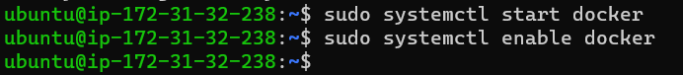



To install Jenkins.





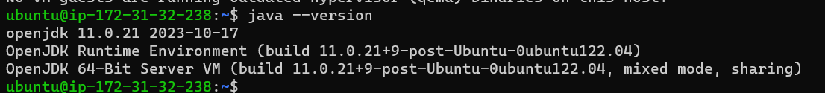

Copy path from internet

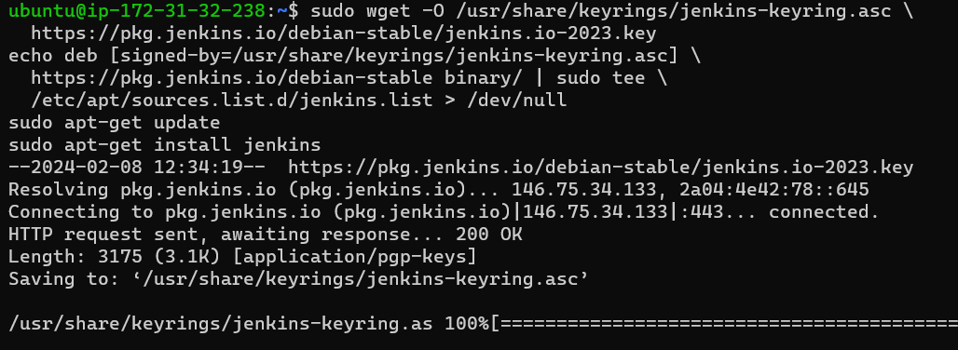

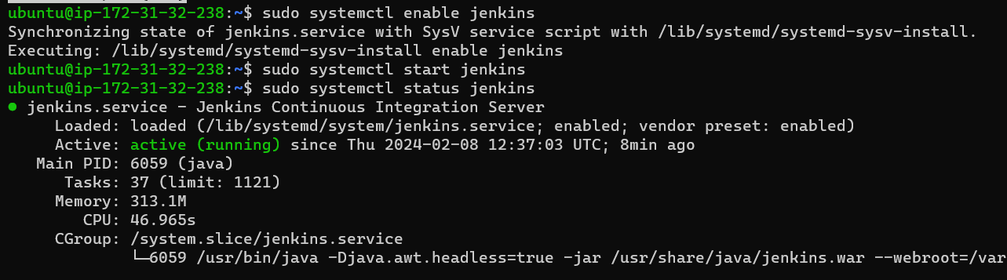

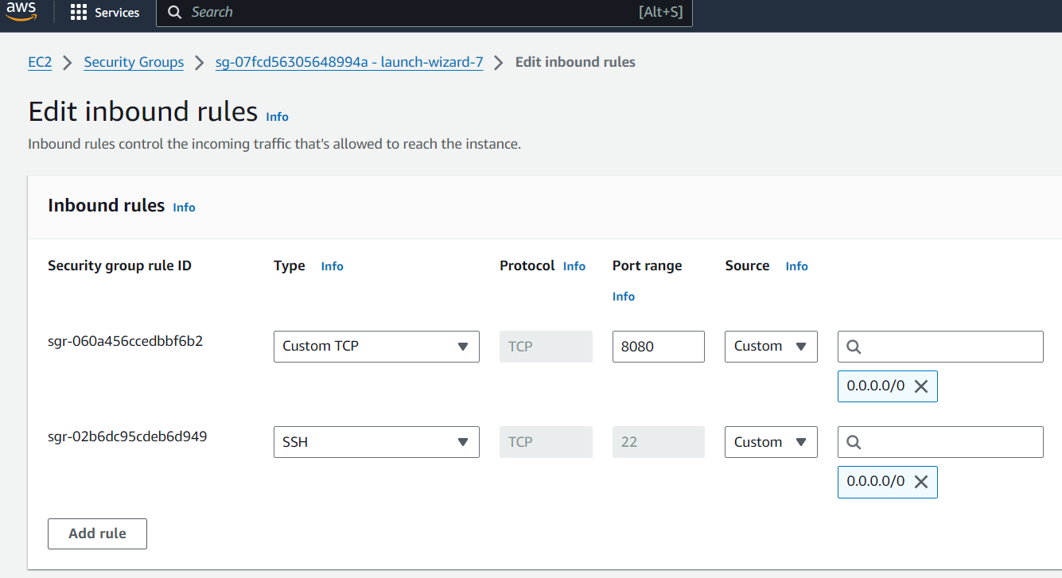

Browse to http://localhost:8080 (or whichever port you configured for Jenkins when installing it) and wait until the **Unlock Jenkins** page appears.

### systemctl and systemd

systemctl is used to examine and control the state of “systemd” system and service manager. systemd is system and service manager for Unix like operating systems(most of the distributions, not all).

The systemctl command interacts with the SystemD service manager to manage the services. Contrary to service command, it manages the services by interacting with the SystemD process instead of running the init script

## Tasks

1. check the status of docker service in your system (make sure you completed above tasks, else docker won't be installed)

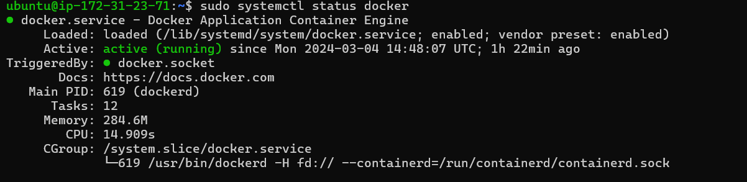

1. stop the service jenkins and post before and after screenshots



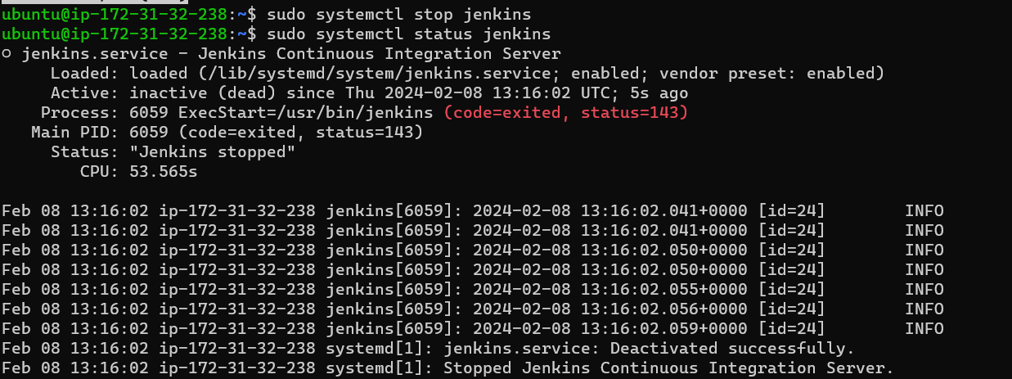

1. read about the commands systemctl vs service

eg. systemctl status docker vs service docker status

### **3.Difference between systemctl and service**

The **systemctl** command interacts with the SystemD service manager to manage the services. In **Service**command, it manages the services by interacting with the SystemD process instead of running the init script.

To start, stop, and restart the service, we can run the respective commands with **systemctl**: 1. To start jenkins service Syntax : **systemctl start jenkins**

2. To stop jenkins service Syntax: **systemctl stop jenkins**

3. To check jenkins status Syntax: **systemctl status jenkins**

4. To enable jenkins service Syntax: **systemctl enable jenkins**

To start, stop, and restart the service, we can run the respective commands with **service**:

1. To start jenkins service Syntax : **service jenkins start**

2. To stop jenkins service Syntax: **service jenkins stop**

3. To check jenkins status Syntax: **service jenkins status**

4. To enable jenkins service Syntax: **service jenkins enable**